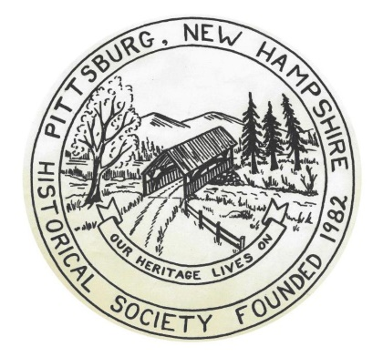
Pittsburg Historical Society
PO Box 2
Pittsburg, NH 03592

Membership Application: New or Renewal

Individual $ 10.00
Family $ 20.00 (Includes one minor child under 18)
Junior $ 5.00 (Under 18)
Lifetime $ 100.00 (Individual)

Dues provide member services, including operating expenses, guest speaker fees, exhibit preparation costs, and assistance in meeting our goals of preserving Pittsburg’s History.
We hope you will join our organization, renew your membership, or make additional donations.

We have purchased a software program to catalog our artifacts and track our membership. Please include your mailing and email address when you return this form so we can update our files. Our goal is to contact you with newsletters and membership notifications via this new system.

Please use this form when remitting your dues and/or donations.

If you have any questions, you can email us at pittsburghistoricalsocietynh@gmail.com

Name: ______________________________________ Amount Enclosed: $_____________

Address: ____________________________________
____________________________________
____________________________________

Email: ______________________________________

Phone: _____________________________________

Membership Type:
Individual _____
Family _____
Junior _____
Life _____
Donation _____

